ARTIFICIAL INTELLIGENCE
2. Intelligent Agents
2.1 Introduction of agents, Structure of Intelligent Agent, Characteristics of Intelligent Agents
2.2 Types of Agents: Simple Reflex, Model Based, Goal Based, Utility Based Agents.
2.3 Environment Types: Deterministic, Stochastic, Static, Dynamic, Observable, Semi-observable, Single Agent, Multi Agent
PAST QUESTIONS:
- Draw and describe the architecture of Utility based agent. How is it different from Model based agent? (D22)
- Compare goal-based agent with knowledge-based agent. (M23)
- Enlist different types of environments and Explain environment for 8 queen problem. (M23)
- Explain Utility Based Agents with diagram. (M23)
- Discuss different types of environments for Intelligent Agents. (D23)
- What are the different types of agents? Explain Goal based agent with a diagram. (D23)
- What is formulation of a problem? Formulate 8-Puzzle problem in terms of following components: initial state, actions, successor function, goal test and path cost. (D23)
NOTES:

*Agents :-
In artificial intelligence, an agent is a computer program or system that is designed to perceive its environment through sensors, make decisions and take actions upon that environment through actuators to achieve a specific goal or set of goals.
A human agent has eyes, ears, and other organs for sensors and hands, legs, vocal tract, and so on for actuators.
A robotic agent might have cameras and infrared range finders for sensors and various motors for actuators.

Structure of an Agent –
Agent = Architecture + Agent program
Architecture is the machinery that the agent executes on. It is a device with sensors and actuators, for example: a robotic car, a camera, a PC.
An agent program is an implementation of an agent function.
An agent function is a map from the percept sequence to an action.

Properties of an Agent -
PEAS: Performance, Environment, Actuators, Sensors.
In AI, PEAS descriptor refers to a framework used to design, define and evaluate the performance of a task or system.
• Performance Measures - used to evaluate how well an agent solves the task at hand.
• Environment - surroundings beyond the control of the agent.
• Actuators - determine the actions the agent can perform.
• Sensors - provide information about the current state of the environment.
Examples –
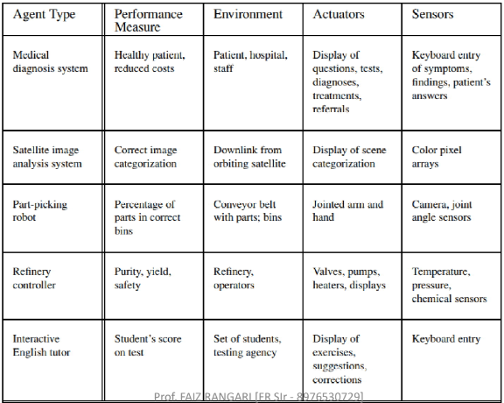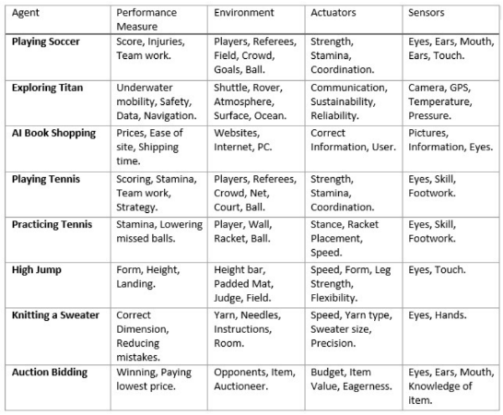
*Types of Agents :-
1. Simple Reflex Agent –
Simple reflex agents ignore the rest of the percept history and act only on the basis of the current percept. Percept history is the history of all that an agent has perceived to date. The agent function is based on the condition-action rule. A condition-action rule is a rule that maps a state i.e., a condition to an action. If the condition is true, then the action is taken, else not.
Imagine yourself as the driver of the automated taxi.
• If the car in front brakes and its brake lights comes on, then you should notice this and initiate braking.
• In other words, some processing is done on the visual input to establish the condition we call “The car in front is braking.” Then, this triggers some established connection in the agent program to the action “initiate braking.”
• We call such a connection a condition–action rule, written as “if car-in-front-is-braking then initiate-braking”.
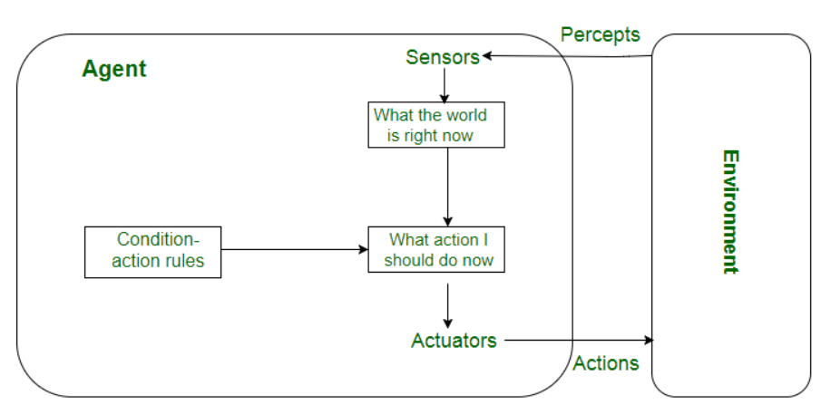
2. Model Based Agent –
A model-based agent can handle partially observable environments by the use of a model about the world. The agent has to keep track of the internal state which is adjusted by each percept and that depends on the percept history. The current state is stored inside the agent which maintains some kind of structure describing the part of the world which cannot be seen.
Updating the state requires the information about −
How the world evolves.
How the agent’s actions affect the world.
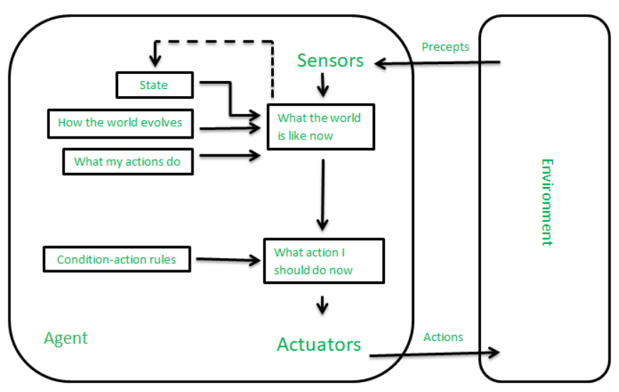
3. Goal Based Agent –
These type of agent keeps track of the world state as well as a set of goals it is trying to achieve, and chooses action that will (eventually) lead to the achievement of its goals.
They choose their actions in order to achieve goals.
The knowledge that supports its decisions is represented explicitly and can be modified, which makes these agents more flexible.
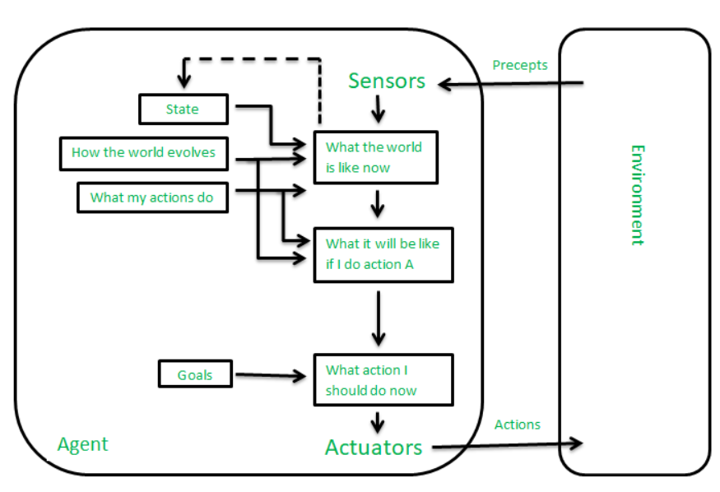
4. Utility Based Agent –
It uses a model of the world, along with a utility function that measures its preferences among states of the world. They choose actions based on a preference (utility) for each state. Sometimes achieving the desired goal is not enough. We may look for a quicker, safer, cheaper trip to reach a destination. Because of the uncertainty in the world, a utility agent chooses the action that maximizes the expected utility.
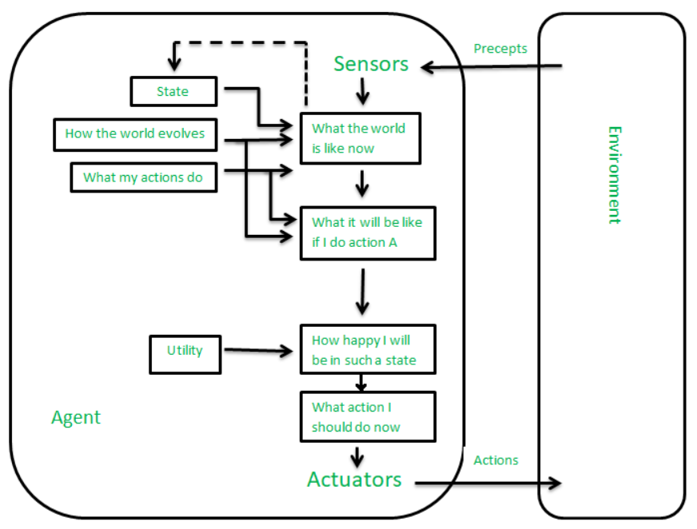
*Environment types :-
Deterministic/Stochastic – If the next state of the environment is completely determined by the current state and the actions of the agent, then the environment is Deterministic.
Stochastic environment is random in nature and cannot be determined by the current state and the actions of the agent.
Static/Dynamic – If the environment does not change while an agent is acting then it is Static.
If the environment changes while an agent is acting then it is Dynamic.
Fully-Observable/Partially-Observable - If it is possible to determine the complete state of
the environment at each point in time then it is said to be Fully-Observable; otherwise, it is
only Partially-Observable.
Single-Agent/Multi-Agent – An environment consisting of only one agent is said to be a Single-Agent environment.
An environment involving of more than one agent is said to be Multi-Agent environment.
Episodic/Sequential – In Episodic environments, the current action does not affect the future decisions, the agent does not need to think ahead as there is no dependency between current and previous actions/decisions.
In Sequential environments, the current decision could affect all future decisions. Chess and taxi driving are sequential.
Discrete/Continuous - If there are a limited number of distinct, clearly defined, states of the environment, the environment is Discrete (For example, chess); otherwise, it is Continuous (For example, driving).

